3/2022

The Prevent Policy

- The Purpose

This policy has been drawn up and implemented to satisfy the Government and regulators such as OFS. The College is fulfilling its duty under the Counterterrorism and Security Act 2015 (the Act) to have due regard to the need to prevent people from being drawn into terrorism (the Prevent duty).

The College supports and promotes education as a place of life-enhancing free expression and enquiry. It deplores the expression and cultivation of views and actions which tend to limit or destroy the lives of others, however extreme or sincere such views or actions may be.

The College regards itself and will sustain itself as a location of democracy, ethical and rigorous enquiry, social and individual improvement, due process, peace, individual liberty, respect, and tolerance.

The College recognises the UK government view that preventing people from being drawn into terrorism requires challenging extremist ideologies. This document is drawn up following the current UK official definition of extremism as 'vocal or active opposition to fundamental British values, including democracy, the rule of law, individual liberty and mutual respect, and tolerance of different faiths and beliefs. The College supports and promotes the Fundamental British Values, which underpin what is to be a responsible citizen in a diverse Great Britain. The College promotes respect for democratic processes and tolerance of different faiths and respect for how the law is made and applied in the UK, supporting equality of opportunity for all and autonomy to know, understand and exercise the rights and personal freedoms.

2. Scope

College members and UK citizens have the right not to be subjected to threats or acts of terrorism. The College will accordingly operate its Prevent duties with energy and diligence.

All other College policies and procedures (e.g., equal opportunities, anti-bullying and harassment) should be understood as completely and functionalizing the Prevent duty.

The College's implementation of this Prevent Policy must not involve covert activity.

Themes to be considered in implementation include necessity and proportionality, consent, the General Data Protection Regulation (GDPR) and the Human Rights Act 1998.

The College will provide OFS and any other relevant regulator with any information required for monitoring compliance with the Prevent duty.

The College will work to the reporting requirements and submission dates set by OFS or any successor body.

3. Prevent Duty Implementation

This policy is linked to the two sets of statutory guidance:

- Revised Prevent Duty Guidance for England and Wales (which includes general guidance for bodies in all sectors covered by the duty)
- Prevent Duty Guidance: for higher education institutions in England and Wales.

The College acknowledges that a key element of the UK government's Prevent strategy is to encourage institutions to address risks of radicalisation. The Counterterrorism and Security Act 2015 (the Act) introduced a package of measures to counter the risk of terrorism and radicalisation. Part 5 of the Act puts hitherto voluntary elements of the Prevent strategy onto a statutory footing. The College became subject to the Prevent duty on 18 September 2015.

The College will respect the freedom of speech duty implicitly applying within higher education. It will respect the importance of academic freedom when issuing guidance. It will implement the two sets of UK government guidance:

- Revised Prevent Duty Guidance: for England and Wales (which includes general guidance for bodies in all sectors covered by the duty) – the 'General Guidance.'
- Prevent Duty Guidance: for higher education institutions in England and Wales – the 'HE Guidance'.

The College will assess the level of risk that College members may be drawn into terrorism, and it will have policies and procedure to mitigate those risks. Partners of the College will need to be acknowledged in its risk assessments proportionately.

The College has considered the OFS advice note at The College will maintain:

https://www.officeforstudents.org.uk/media/3e9aa5d3-21de-4b24-ac21-18de19b041dc/ofs2018__35.pdf

- Prevent risk assessment
- Action plan
- Policies and procedures for managing and mitigating the risks around external speakers and events on campus and institution-branded events that are taking place off-campus. Such policies will reflect the institution's duty to ensure freedom of speech on campus and its arrangements to protect the importance of academic freedom.

The College will pay particular attention to:

- Senior management and governance oversight of implementing its Prevent duty obligations and engagement with Prevent partners.

- Engaging with and consulting students on the institution's plans for implementing the Prevent duty.

- Training appropriate staff about Prevent.

- Sharing information internally and externally about vulnerable individuals.

- Sharing information about external speakers with other institutions, where legal and desirable.

- Ensuring sufficient pastoral support for all students (including arrangements for managing prayer and faith facilities).

- The use of the institution's computer facilities (hardware, software, networks, social media), including considering filtering arrangements and academic activities that might require online access to sensitive or extremism-related material.

- Engaging with student organisations, which are not subject to the Prevent duty, but are expected to cooperate with the College.

- The UK 'Channel’ programme. ('Channel' is an early-intervention, multi-agency process designed to safeguard vulnerable people from being drawn into violent extremist or terrorist behaviour. Channel panels chaired by local authorities bring together multi-agency partners to assess the risk for an individual and decide whether a support package is needed.)

The College will attend to:

- An annual report from the governing body or proprietor on the implementation of the Prevent duty in the previous operation or academic year, including any significant developments up to the date of the report.
- Regulatory body assessment on a multi-year cycle.

Any serious incident in the Prevent area will lead the College to review its approach to the Prevent duty: risk assessment, action plans, training, management, and governance oversight.

The College will inform OFS, or any successor body, of any serious adverse event or serious reportable incident in the Prevent area. The College recognises that reporting an incident to OFS is not a substitute for reporting it to the police or other appropriate authority – for example, if criminality is suspected. Senior management will engage with partners, including the police, the Prevent coordinators, and students.

Risk assessment will consider how and where students might be drawn into terrorism (including violent and non-violent extremism). It will consider whether student, staff welfare and other similar policies cover these issues. The College will scrutinise whether policies and procedures for events held by staff, students and third parties are effective. The Prevent action plan will mitigate identified risks.

For sharing information about vulnerable people, the internal mechanism is an immediate report to the principal. External agreements for the sharing of information about vulnerable people will be drawn up and operated. The College legally agrees that transfer of information on Prevent themes is paramount.

In the context of Prevent duties, the College will apply its welfare policies and procedures and its general preference for open-door consultation.

The College will set aside a room if requested, for prayer, meditation, or general thoughtfulness. It upholds the principle that the room should be equally available to those of any or no faith, including for the storage of religious books and other articles. At the same time, it acknowledges that some faiths favour certain days, times, and practices, and it asks and expects other members of the College to respect such preferences. Any competition for or dispute over the use of such a room shall be immediately referred to the principal, whose decision will directly apply, pending any further discussion within the formal College processes. The College upholds the principle of transparency in its academic and social life: no person of another or no faith will be excluded at any time from a room set aside for prayer, meditation, or general thoughtfulness.

Operating under the part of the UK tradition representing tolerance and openness, the College respects the right of college members to express their religious beliefs. However, the expression of belief must not breach UK law, must not amount to bullying or harassment, and should respect the right of other College members to study and learn what they wish and how they wish within the law and within the conventions of UK higher education. Given their position of authority and influence, College staff is required to be particularly careful in any kind of expressions of their beliefs; the expression of political or religious beliefs, either personal or that of others, within the academic setting requires intensive care.

No part of the College's estate or equipment may be used for illegal purposes. The College will keep records of student attendance, performance, library use, and use of College IT and other electronic equipment.

Student groups and societies may meet on-campus for social and academic purposes with the written permission of the principal. All such meetings must be arranged with an invitation to attend as an observer for the Principal or the Principal's representative(s). No meeting shall be held which may reasonably be promoting terrorism or extremism (as defined in this document) or encouraging any illegal activity or any other activity contrary to college rules. The principal may refuse permission for a meeting.

INDICATORS OF VULNERABILITY TO RADICALISATION

Radicalisation refers to the process by which a person comes to support terrorism and forms of extremism leading to terrorism.
Extremism is defined by the Government in the Prevent Strategy as:

Vocal or active opposition to fundamental British values, including democracy, the rule of law, individual liberty and mutual respect and tolerance of different faiths and beliefs. We also include in our definition of extremism calls for the death of members of our armed forces, whether in this country or overseas.
Extremism is defined by the Crown Prosecution Service as:

The demonstration of unacceptable behaviour by using any means or medium to express views which:
- Encourage, justify or glorify terrorist violence in furtherance of particular beliefs;
- Seek to provoke others to terrorist acts;

- Encourage other serious criminal activity or seek to provoke others to serious criminal acts; or
- Foster hatred which might lead to inter-community violence in the UK.

There is no such thing as a “typical extremist”: those who become involved in extremist actions come from a range of backgrounds and experiences, and most individuals, even those who hold radical views, do not become involved in violent extremist activity.

Pupils may become susceptible to radicalisation through a range of social, personal and environmental factors - it is known that violent extremists exploit vulnerabilities in individuals to drive a wedge between them and their families and communities. It is vital that Centre staff are able to recognise those vulnerabilities.

Indicators of vulnerability include:
  - Identity Crisis – the student / pupil is distanced from their cultural / religious heritage and experiences discomfort about their place in society;
  - Personal Crisis – the student / pupil may be experiencing family tensions; a sense of isolation; and low self-esteem; they may have dissociated from their existing friendship

group and become involved with a new and different group of friends; they may be searching for answers to questions about identity, faith and belonging;
  - Personal Circumstances – migration; local community tensions; and events affecting the student / pupil’s country or region of origin may contribute to a sense of grievance that is triggered by personal experience of racism or discrimination or aspects of Government policy;
  - Unmet Aspirations – the student / pupil may have perceptions of injustice; a feeling of failure; rejection of civic life;
  - Experiences of Criminality – which may include involvement with criminal groups, imprisonment, and poor resettlement / reintegration;
  - Special Educational Need – students / pupils may experience difficulties with social interaction, empathy with others, understanding the consequences of their actions and awareness of the motivations of others.

However, this list is not exhaustive, nor does it mean that all young people experiencing the above are at risk of radicalisation for the purposes of violent extremism.

More critical risk factors could include:
  - Being in contact with extremist recruiters;
  - Accessing violent extremist websites, especially those with a social networking element;
  - Possessing or accessing violent extremist literature;
  - Using extremist narratives and a global ideology to explain personal disadvantage;
  - Justifying the use of violence to solve societal issues;
  - Joining or seeking to join extremist organisations; and
  - Significant changes to appearance and / or behaviour;
  - Experiencing a high level of social isolation resulting in issues of identity crisis and / or personal crisis.
Refer to
The Prevent Duty for further details.

The UKCB will evaluate its performance of this policy on a yearly basis.

Safeguarding Contacts:

Name Role Contact
Yewande Ogunsanya | Safeguarding Lead DSL / Lecturer | Tel: 07944852995  Email:safeguarding@ukcb.world
Hania Regman | DDSL HR and Support Officer | Tel: 07856389729  recruitment@ukcb.world
Raj Sourabh Lahiri | Lecturer / Student Support / Cyber Security | Tel: 07843 534908  Email:student support@ukcb.world
Hakan Gokce | DDSL / Consultant | Tel: 07585344051  Email: hakan.gokce@axiseducationaltrust.org
Joshua Rogers | Digital Community Manager / Student Support | Tel: 07474 675872  Email: josh@ukcb.world
External
Multi-Agency Safeguarding Hub Barnet Council | The Mash Team | Tel: 0208 359 4066 Out of Hours: 0208 359 2000.
Barnet Council | LADO (Allegations against staff) | Tel: 0208 359 4066 Out of Hours: 0208 359 2000
Barnet Police | In case of Emergency | 999

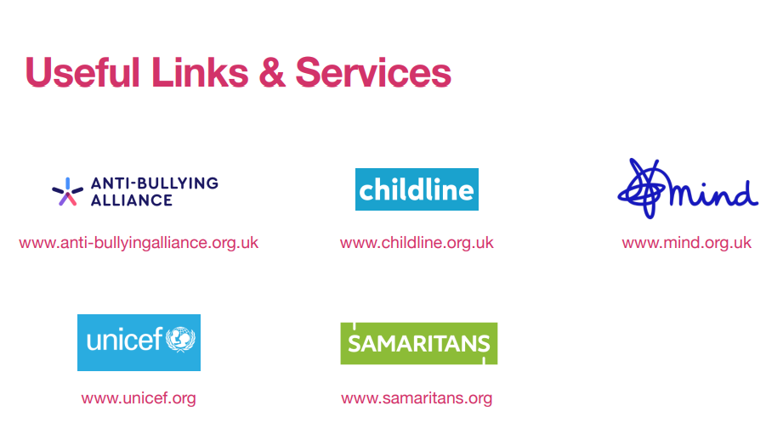

Useful references and organisations
    - London Safeguarding Children Board www.londonscb.gov.uk
    - ‘What to do if you’re worried a child is being abused.’ Published by DFES 04320- 2006
    - National Society for the Protection of Children www.nspcc.org.uk
    - Kidscape www.kidscape.org.uk
    - Stonewall www.stonewall.org.uk
    - The Safe Network www.safenetwork.org.uk
    - Child Line 0800 11 11 www.childline.org.uk
    - Guidance for Safer Working Practice for Adults who work with Children and Young People in
    - Education Settings. March 2009
    - Barnado’s www.barnados.org.uk
    - www.horsesmouth.co.uk Mentoring site where users can give and receive confidential advice.
    - http://www.thehideout.org.uk/

Below is a selection of useful teaching resources on domestic abuse/violence for Centres
    - ‘Is this Love?’ Lesson plans and guidance for Centres
    - http://www.devon.gov.uk/adva-education-pack.pdf
    - Respect Training Resources for primary and secondary Centres – developed in Scotland but an excellent resource for use in all Centres. www.zerotolerance.org.uk
    - ‘Stop Hitting Mum’ – Children talk about domestic violence (2003) Mullender A, et al Young Voice.
    - ‘Hitting and Hurting – Living in a Violent Family’ Pickering, F (2000) The Children’s Society.
    - ‘Child protection and domestic violence’ Mullender A, Dobbonair T (2000) Venture Press.
    - The Woman who Walked Into Doors, Roddy Doyle, Random House (1997).
    - Children’s Perspectives on Domestic Violence, Mullender A, Hague G, and Regan L (2002), Sage

